**Name:**

**CSC 229 Test 3 100 Points**

***Download the java files, create a new project and copy them to the project. Complete the exam by copying the code from your program to this file, save the file as a Microsoft Word file labeled as “your last name-your first name ”, submit through BB and via email with a subject line that reads as “CSC 229-01 – Test 3 – your last name-your first name” on or before 3:10PM***

***Late submissions are subject to 20% penalty per every 5 minutes***

**(20) 1. Complete the method subtractArray (at the end of Test3.java file) so that given two 1D array of integers A and B as input arguments, returns a 1D array of integers C where:**

**C[i] = A[i] - B[i]**

**Note: check for compatibility. DO NOT worry about actionPerfored or paint for this problem.**

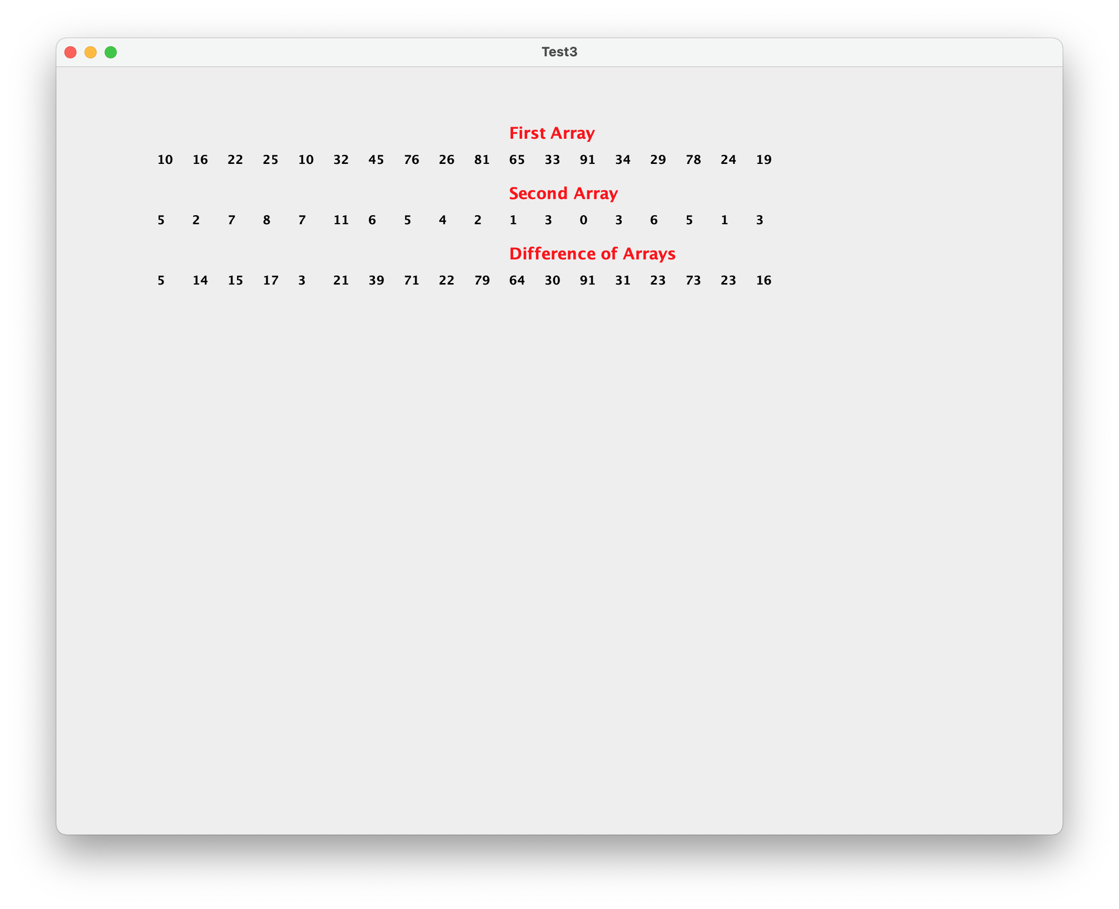

**(20) 3. Develop a method equal2D that given two 2D arrays of integers a and b as the input arguments returns:**

**true iff a[i] [j]= b[i][j] for all elements of the two arrays**

**false otherwise**

**Note: check for compatibility**

**DO NOT worry about actionPerformed or Paint methods.**

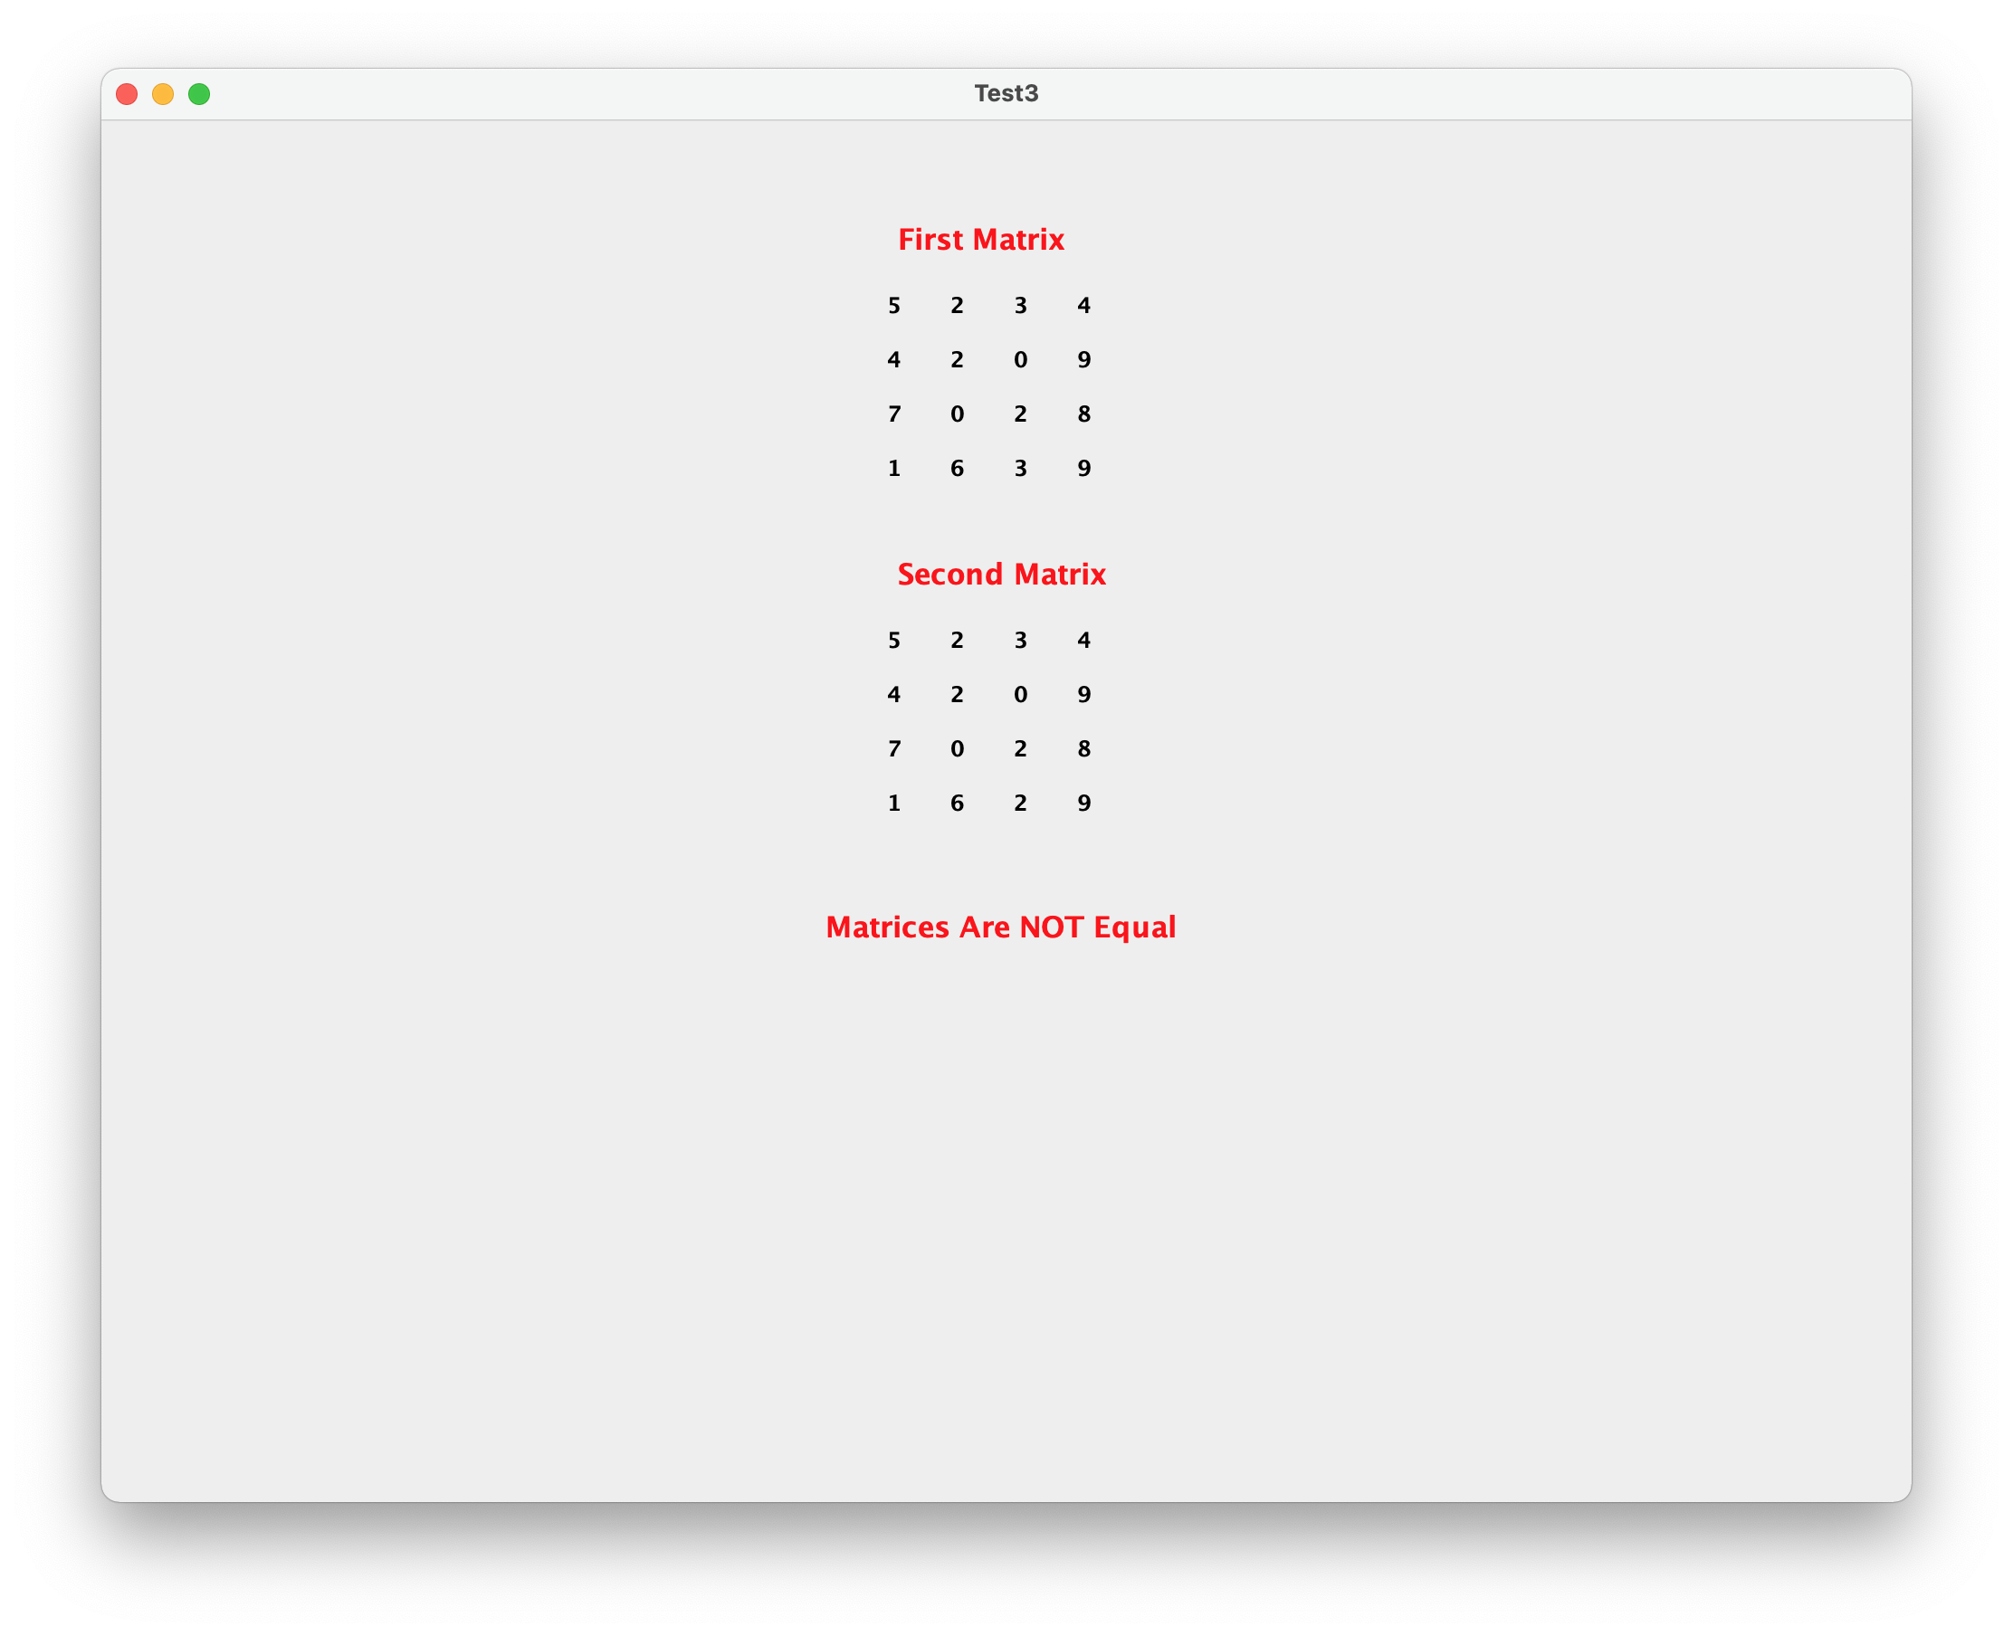

**(25) 3. Develop case “Problem 3” in paint method to draw the following shape in the middle of the screen based on the current width and height of the screen, leave 20 pixels from the borders. Divide the bounding rectangle into 4 equal segments.**

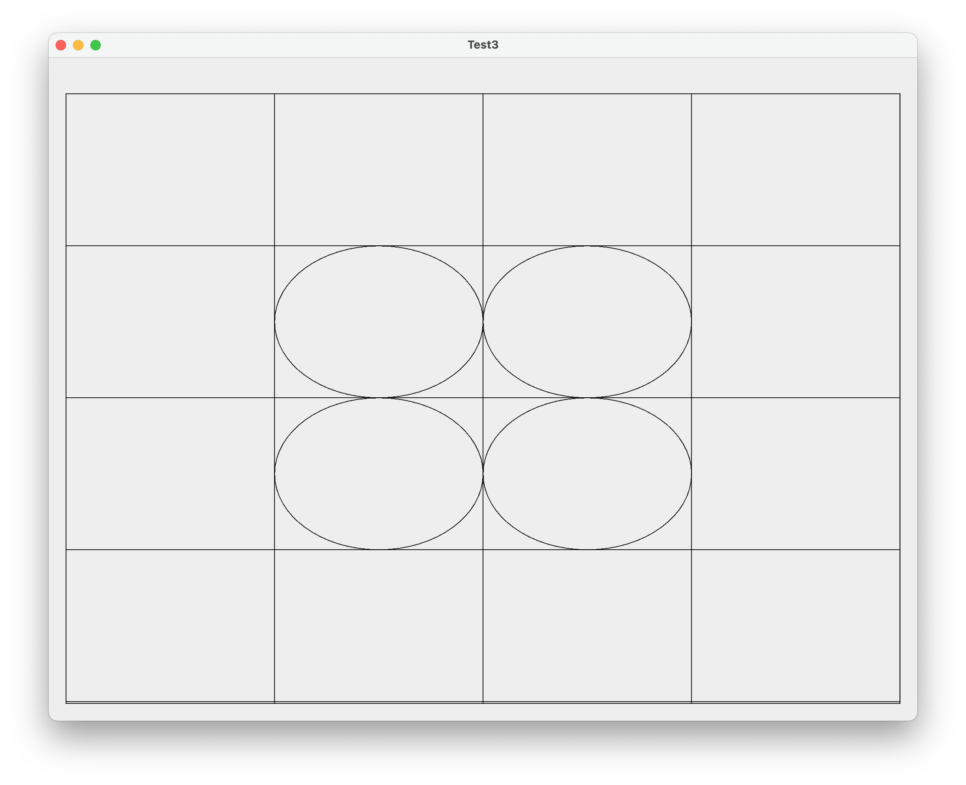

**(25) 4. Design a class called Circlem to represent a Circle. A Circle is identified by coordinates of its cente (xCenter, yCenter) and its radius) (radius) Class should have methods to return xCenter, yCenter, radius and perimeter and area (no getAttribute or toString needed).**

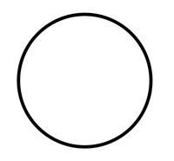

* **Perimeter (2 * p * radius)**
* **Area (p * radius2)**

